|  |
| --- |
| Waynell Lovell |
| Hill Truck Challenge |
| **[Platform Game** |
| Version #1.00  All work Copyright © 2012 by Waynell Lovell Games.  All rights reserved. |
| **Waynell Lovell** |
|  |

logo

|  |
| --- |
| June 26th 2016 |

**Table of Contents**

Version History 3

Game Overview 4

**V****ersion History**

Github: https://github.com/WaynellLovell/Assignment02-Platformer

1. **Game Overview**

The player drives the truck and tries to make it to the end of the map before times is up or they are out of fuel.

1. **Game Play Mechanics**

*Arrow keys or A,W,S,D keys*

1. **Camera**

*Focus on player*

1. **Controls**

*Arrow keys or A,W,S,D keys*

1. **Saving and Loading**

*none*

1. **Interface Sketch**

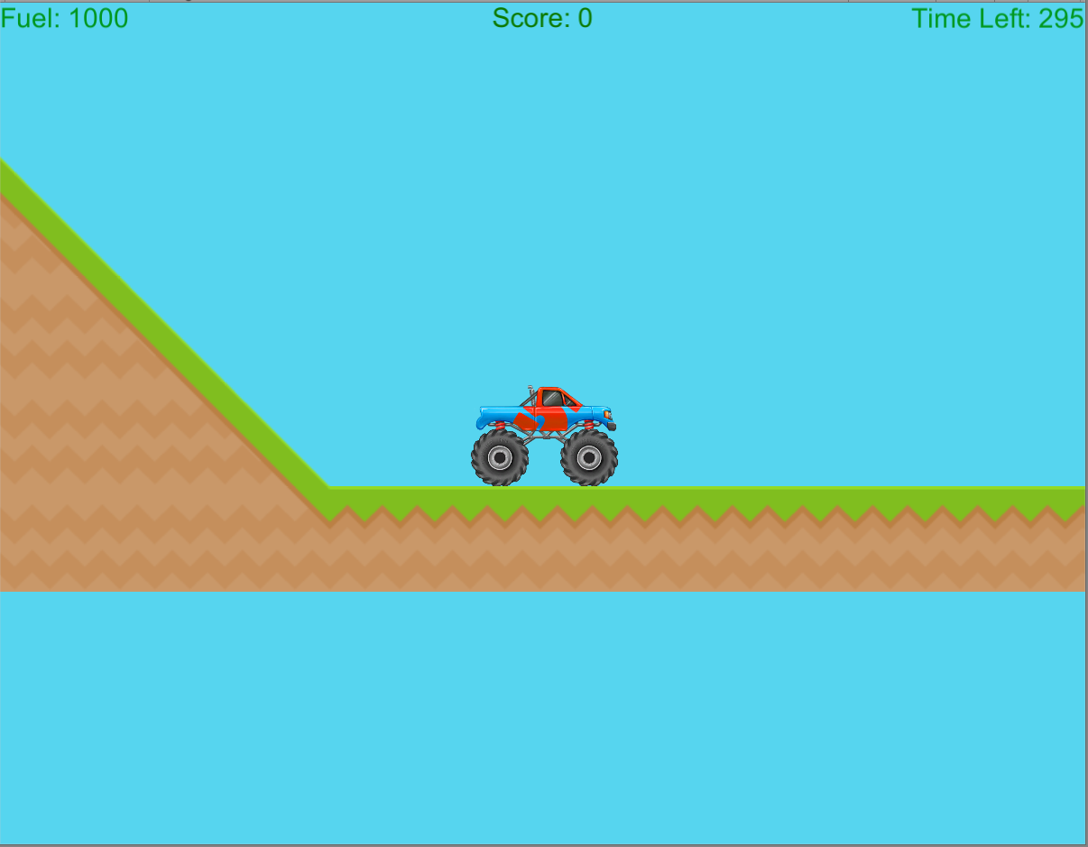

1. **Game World**

*Nothing fancy.*

1. **Characters**

*truck*

1. **Items**

*Fuel to drive further*

1. **Script**

CarMovements

FuelController

GameController

1. **Scoring**

Distance traveled

1. **Sound Index**

Engine_Sound

GameFInishSound

Tires_Screech

1. **Art / Multimedia Index**

*A lot of sprites*